DASH vSphere VM Access Guide

Input Guide
This section outlines the input parameters required for provisioning vSphere Virtual Machines using the DASH Portal. Each parameter includes a description, available options, usage guidance, and notes on valid combinations when applicable.
Input Parameter | Description | Values Provided | Value Guidance | Valid Combinations
os_template | The base operating system template or image used to create the virtual machine. | dash_ubuntu_2204_template,  dash_ubuntu_2204_desktop_template,  dash_ubuntu_2004_template,  windows-server-2019-datacenter-core | Choose OS based on workload requirements. | N/A
deployment enclave | The physical hardware vendor where the VM is deployed. | cisco01, cisco02, hpe01, hpe02 | Cisco and HPE are the hardware vendors; choose the appropriate one based on your deployment requirements. | N/A
hostname | A unique name for the VM within the cluster | Use clear naming conventions for resource management. | Use clear naming conventions for easier resource management. | N/A
cpu_count | The number of virtual CPUs (vCPUs) to allocate to the VM. | CPU Count:  1, 2, 3, 4, 5, 6, 7, 8 | Choosing the right vCPU count depends on the application workload, lightweight services may need 1 - 2 vCPUs, while compute-intensive applications may need more. | N/A
allocated memory(GBs) | The amount of memory to allocate to the VM. | Allocated Memory:  1GB, 2GB, 3GB, 4GB, 5GB, 6GB, 7GB, 8GB | Sufficient memory should be allocated based on workload requirements. | N/A
volume size(GBs) | The size of the virtual disk required for the VM. | Volume Size:  20, 30, 40, 50, 60, 80, 100 | Storage should be sized according to workload needs. | N/A
Services expire after 30 days. Create this service now, or schedule for a later date? | VM will be deleted 30 days after creation, or it can be scheduled to be created at a later date. | Create Now (or)  Schedule for Later | Choose based on VM requirements. | N/A

Sample Input Selection:

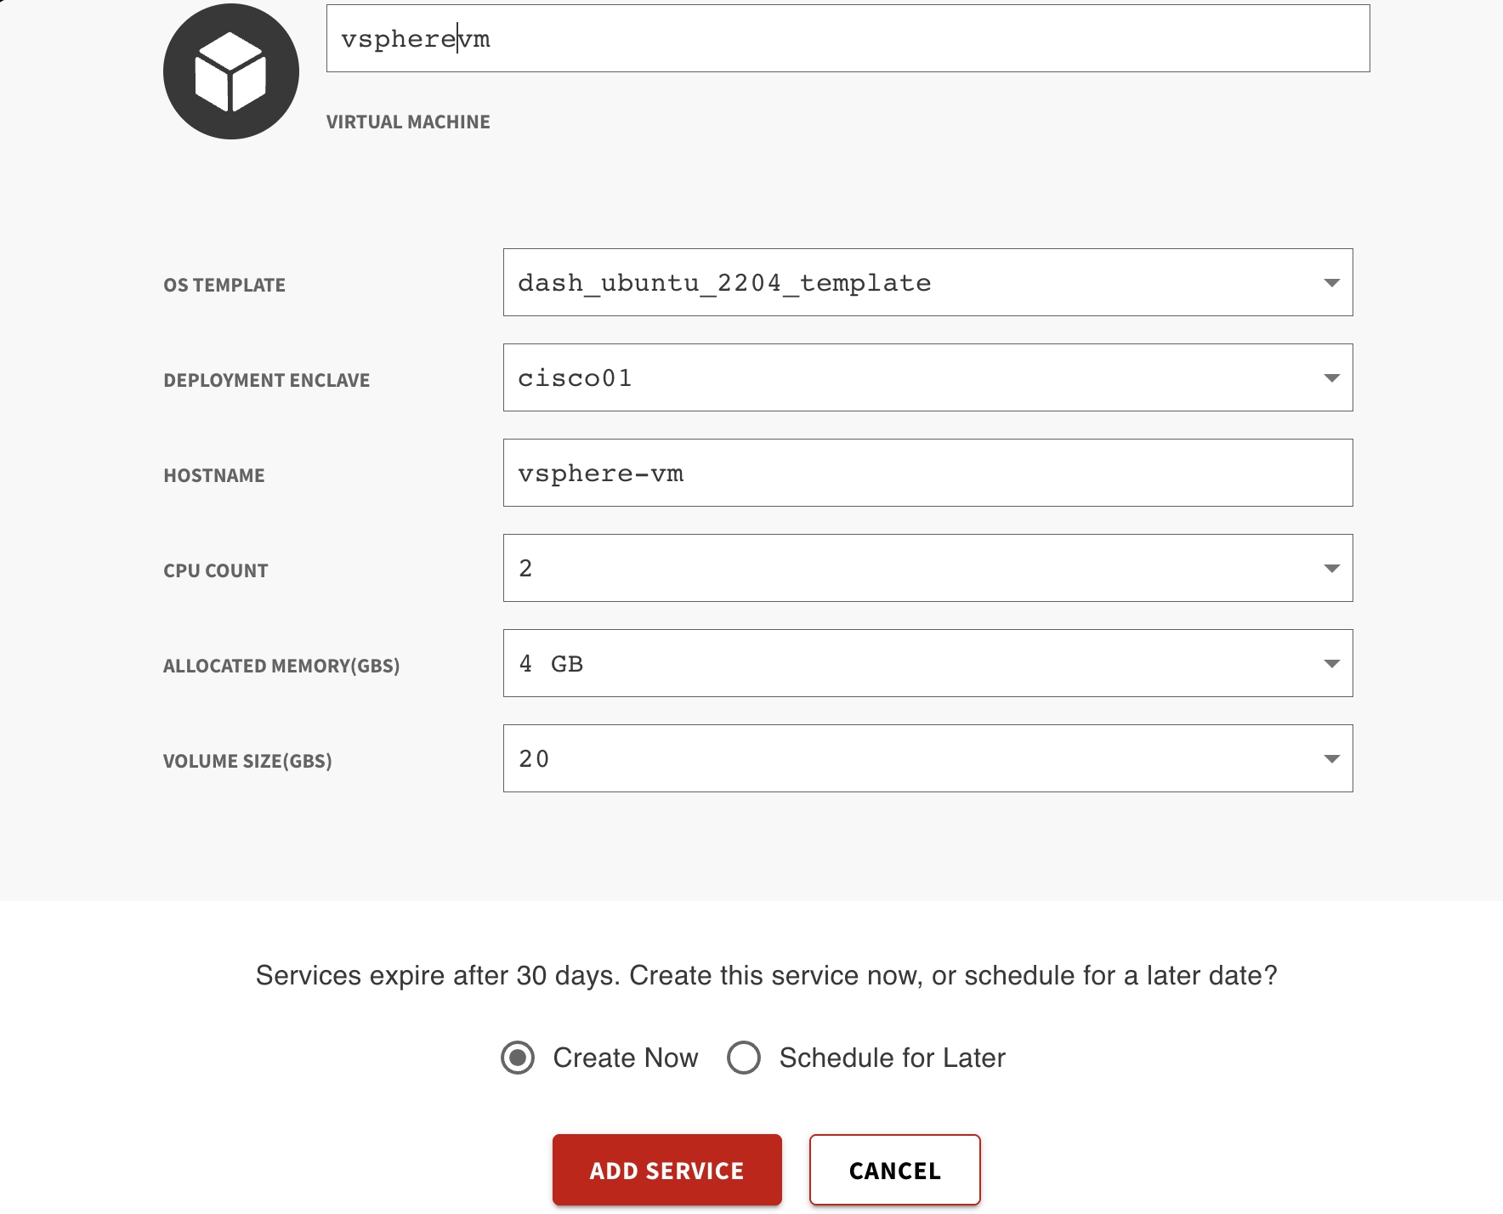

Output Guide
This section outlines the output values generated after vSphere Virtual Machine provisioning through the DASH Portal. These outputs can be used to access, manage, and connect to your virtual machine.
Outputs | Description | Example Value
enclave | Dash enclave where the resource lives. | prj-8WbNLes4W88TJWEL
ip_address | Public IP address of the VM | 10.89.154.196
ssh_password | Password to SSH into the host | 2l>alH81S
ssh_username | Username for the server to log in. | dash
vm_name | Name of the virtual machine created. | oqamj4sr-WoYB

What you can do with these outputs:
Use the following commands to connect to and manage your vSphere Virtual Machine. Replace placeholder values like <public_ip_address>, <ssh_username>, etc., with the actual outputs provided during provisioning.
1. SSH into the Virtual Machine (Linux-based OS)
Command:
ssh <ssh_username>@<public_ip_address>

Example:
ssh dash@10.89.154.196
2. RDP into the Virtual Machine (Windows-based OS)
1. Open Remote Desktop Connection (mstsc on Windows).
2. Enter the Public IP Address (e.g., 10.89.154.196).
3. Use the username (ssh_username) and password (ssh_password) from the outputs.

